Design of the project

The circuit is a simple and minimalistic circuit which can be fitted into any helmet by making very simple modifications to the helmet without changing any of the aesthetics of the helmet.

All the components off the circuits have been made as small as possible to make it easy to fit into the helmet and add a very important function.

Due to the small size of the and almost no intrusions felt by the rider, the project causes no discomfort to the rider and ensures that the rider has a safe ride.

The connections made to the bike are simple as well which makes it easier to practically implement this for the general public.

with the bare basic circuitery and compact size, our project ensures a practical and implementable solution to the major problem of helmetless riding.

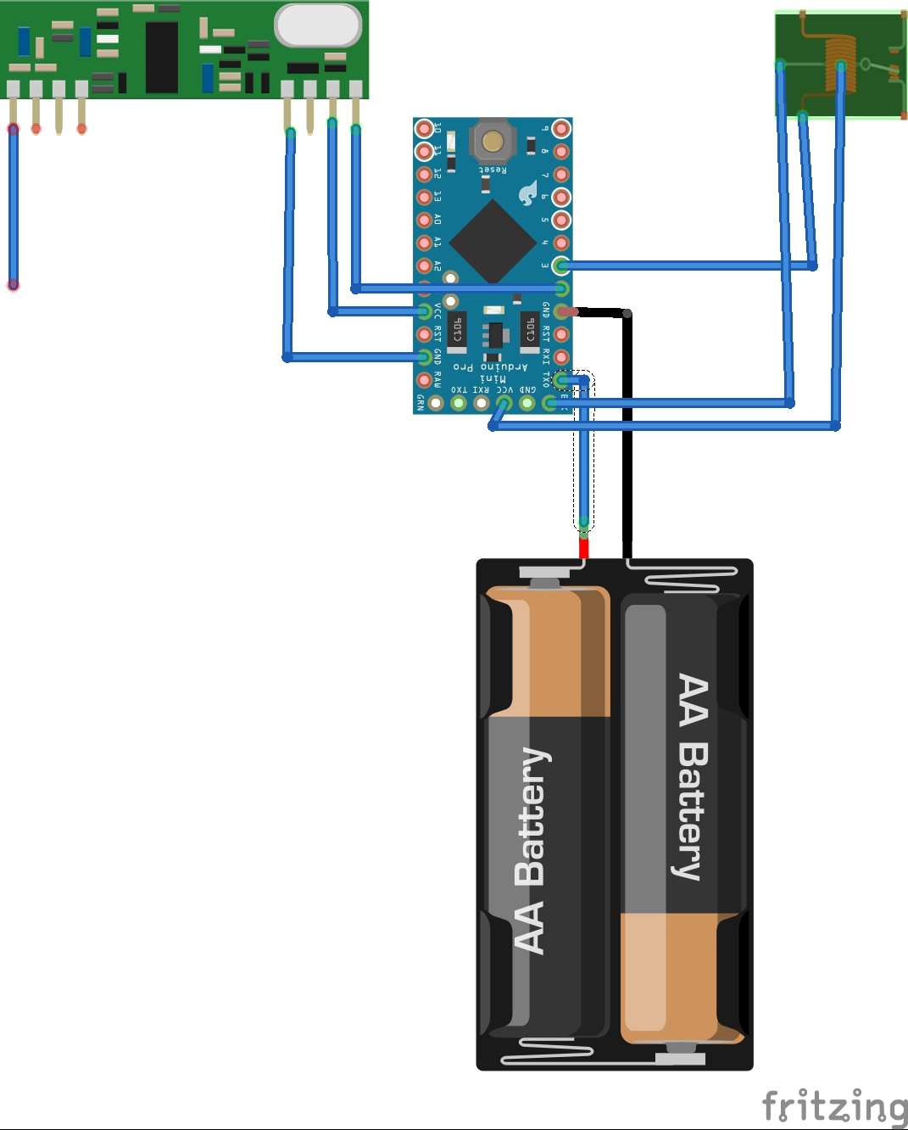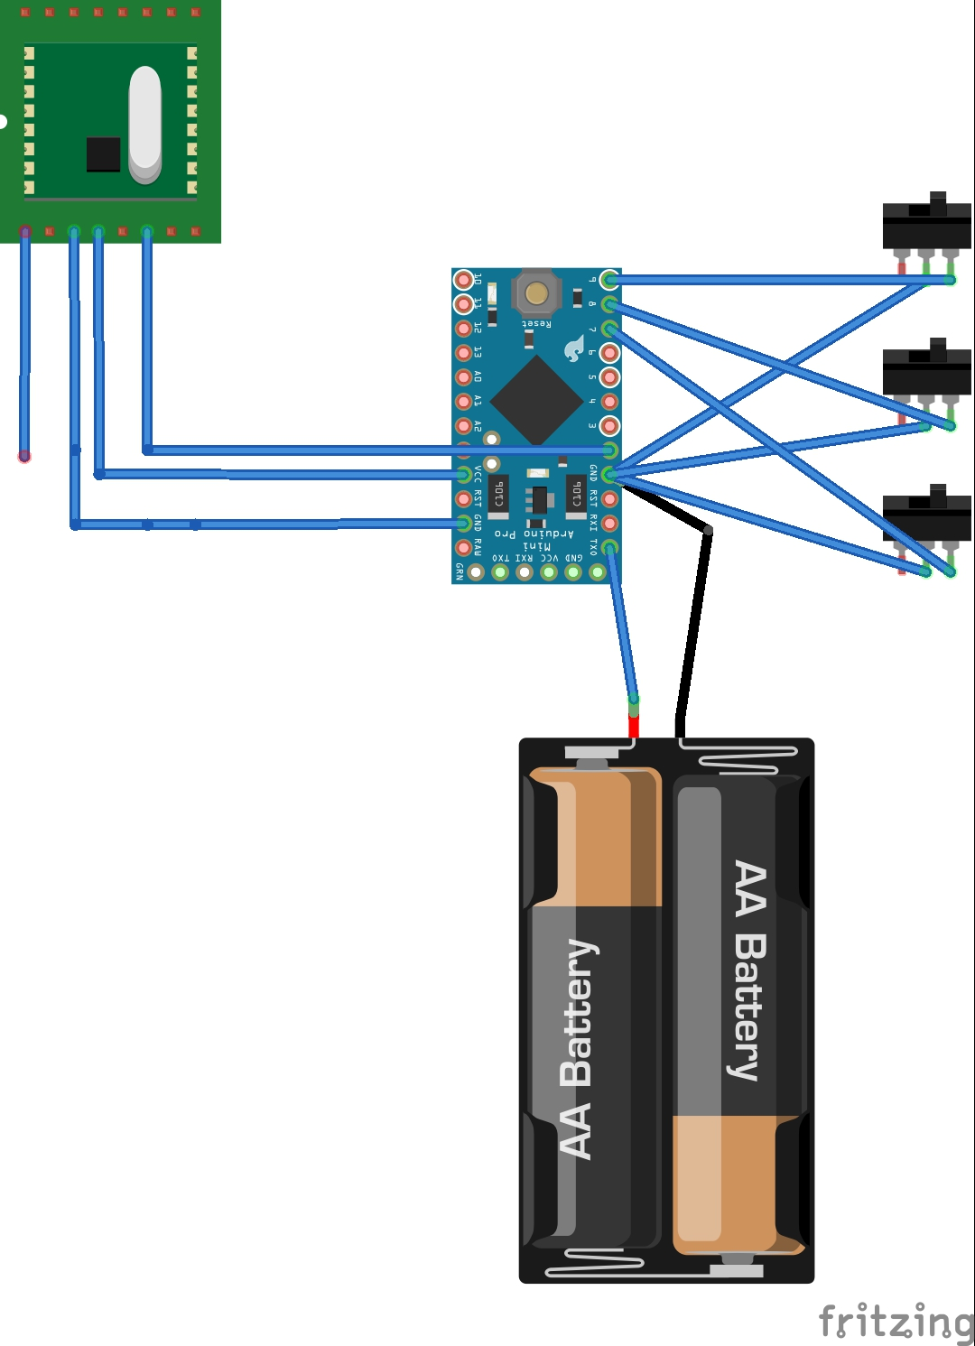

Receiver module transmitter module

**Bibliography**

**PRIMARY SOURCES**

* **www.ieeexplore.ieee.org/document16895036/?reload=true**
* **Ijser.org/research paper/intelligent-helmet-pdf**
* **Publication/271139060-smart-helmet**

**SECONDARY SOURCES**

* **www.researchgate.net**
* **Ijarece.org/wp.content/uploads12016/02/irarece-VOL-5 ISSUE-7-151-152.pdf**
* **Ijerat.com/uploads/2/3200-pdf.pdf**